CHAPTER 15

Escape from Vietnam to Marine Camp Pendleton

In February 1975, I was in France with the Minister of Education Ngo khac Tinh and his Deputy Do ba Khe. At that time, I was the Technology advisor to the Minister of Education. The French government invited us to visit the Paris Grandes Ecoles and the famous universities of Bordeaux, Toulouse, Montpelier, Aix- en- Provence, l’Institut Technique de Compiegne and INSEAD (Institut Européen d'Administration des Affaires or European Institute of Business Administration.)

Politically there was in Vietnam a rivalry between France and the US in higher education. In colonial days Vietnam adopted the French model. Since US intervention in the country in 1952, many new Vietnamese graduates from the US universities came home and worked for the ministry of education. They brought back new ideas from the US. The French government desired to continue to extend its influence in the cultural activities of its former colony.

Upon our return to Saigon, we learned that the military situation was not bright, especially in the highlands. The North Vietnamese infiltrated down the Ho chi Minh trails in greater number. The US was cutting aid to Vietnam for the benefit of Israel. It was a known secret that Secretary of State Henry Kissinger and the US Congress were under strong, efficient and effective lobby from the Jewish community to help Israel. On the other hand, the Communists in the North knew they were solidly backed by Red China and Russia without any congressional type of restriction.

The South Vietnamese army began to cannibalize helicopters and airplanes for spare parts. The heavy artillery shells were restricted to a minimum. The enemy knew all of this. The atmosphere was very demoralizing. Secretly and silently many informed persons felt it was a matter of time! Of course, most of us kept working to maintain the national spirit.

There was scary talk about the blood bath planned by the communists for those of us serving the government. Many times in a small gathering we were brain storming among ourselves to find possible ways to avoid being captured and tortured by the enemy. I myself thought that as a last solution, I would use a few ripe coconuts tied together as a float on the Mekong River, hoping some friendly boats would pick me up. It may be silly but when forced into a corner, the instinct of survival will react. Some of us thought of getting suicide poison pills to avoid torture. At the end, I had to believe also in fate or destiny. It was one of the most painful periods of my life.

One day, I went to the USAID (US Agency for International Development) office for one of my regular meetings. To my shock, the building was almost empty. I went to Von Spiegelfeld’s office. He was a good friend and the third man in USAID. I locked the door and looked a him straight in his eyes: “My friend, please tell me what’s going on?” He said “if I were you, I would escape.” I thanked him and left. Apparently a few days earlier they had received a secret order to leave Vietnam.

They never let their Vietnamese counterpart workers know that.
A fateful day: 23 April, 1975. I was working in my office and after the daily routine staff meeting, I continued my way to the Ministry of Economy for a weekly conference. I was almost to my car when a staff member let me know that I had an urgent call from home. I returned to my office on the second floor. Marie, my wife, told me that my nephew-in-law, Tom Forbes, a decoding employee at the US Embassy, was at home and wanted to talk to me. On the phone Tom refused to say anything except asking me to return home immediately to see him. When I arrived, Tom was a little nervous and handed me a letter from his shaking hand. The letter contained a secret address of a private villa organized by the CIA for the emergency evacuation. It had also the list of names of my niece’s family members.
I should go immediately to that evacuation point.

I took a last look at my home. Then, Marie and I left with a small handbag of clothing. That was how my wife and I were saved from communist capture and torture. Thank God for a second chance! At the villa, we were surprised to see ahead of us many, many U S Defense Department regular employees waiting to be transferred secretly to Tan Son Nhut airport by civilian buses.

Consulate evacuation list from Tom’s hand
(See attached photo below)
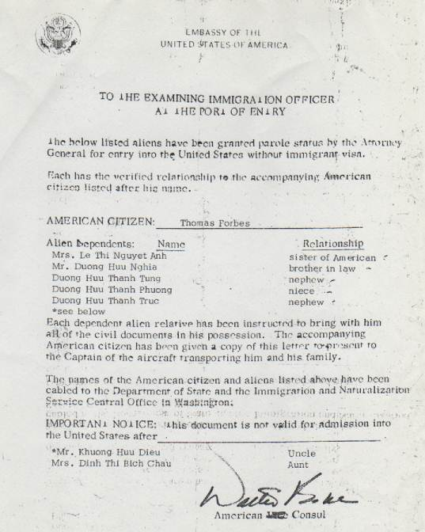

Please note at the bottom of the letter, there was an asterisk to add my name and my wife names as Uncle and Aunt.
Here again was a fateful act of God. This piece of paper was my second
“Birth certificate.” Several weeks before this fateful day, my niece took my wife to Tan Son Nhut airport to get her out of Saigon, already
surrounded by communist forces. I had to stay behind and work.
But US law allowed the evacuation of blood parents only. An aunt was not accepted. Marie had to return home that day.
Very fortunately, Newsweek Magazine dated April 21, 1975 had an interview with me. (See attached copy)

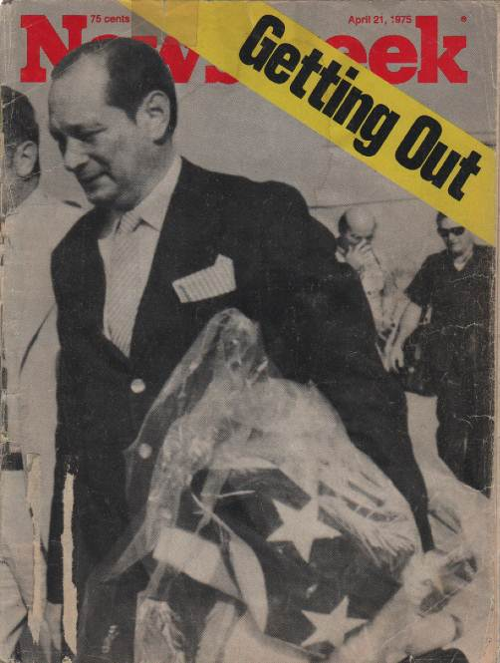

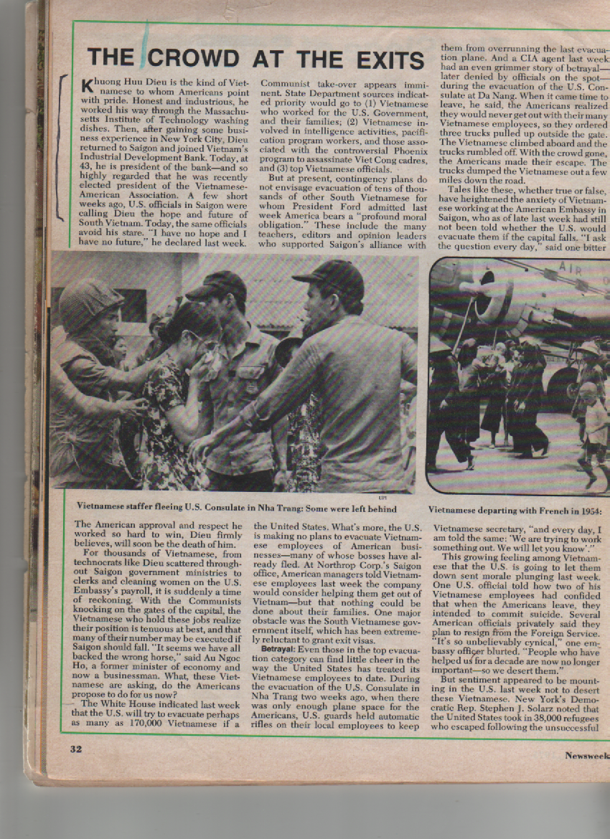

In early April 1975, I was interviewed by Newsweek reporters MILTON R BENJAMIN with NICOLAS C PROFFITT. I seized this opportunity to express myself forcefully, explaining that my abilities might be of use to a communist government, but that as President of the Vietnamese-American Association (Hoi Viet My), a very high profile organization in Saigon with about 25,000 students learning English and other national cultural exchange activities, I would not live through a change to a communist government. Newsweek April 21, 1975 run the story with the lead line (page 32)

“THE CROWD AT THE EXITS “

“Khuong Huu Dieu is the kind of Vietnamese to whom Americans point with pride. Honest and industrious, he worked his way through the Massachusetts Institute of Technology washing dishes. Then, after gaining some business experience in New York City, Dieu returned to Saigon and joined Vietnam’s Industrial Development Bank. Today at 43, he is president of the bank—and so highly regarded that he was recently elected president of the Vietnamese-American Association. A few short weeks ago, U.S. officials in Saigon were calling Dieu the hope and future of South Vietnam. Today, the same officials avoid his stare. “I have no hope and I have no future,” he declared last week. The American approval and respect he worked so hard to win, Dieu firmly believes, will soon be the death of him.
For thousands of Vietnamese, from technocrats like Dieu scattered throughout Saigon government ministries to clerks and cleaning women on the U.S. Embassy’s payroll, it is suddenly a time of reckoning. With the Communists knocking on the gates of the capital, the Vietnamese who hold these jobs realize their positions tenuous at best, and that many of their number may be executed if Saigon should fall.” It seems we have all back the wrong horse” said ….a businessman.
…Several American officials privately said they plan to resign from the Foreign Service.” It’s so unbelievably cynical”, one embassy officer blurted. People who have helped us for a decade are now no longer important---so we desert them”…..
But whatever the problems, most Vietnamese with U.S. ties clearly preferred evacuation to being left behind to take their chances with the Communists. “My abilities as a banker might be useful to the North Vietnamese,” bank president Dieu said last week, “but all they will see is that I was president of the Vietnamese-American Association. That alone will be enough to put me in my grave. All we ask is that you be fair to us. We want to stay until the last day. But on that last day, we want to go out with our friends--the Americans.”
“Milton R. Benjamin with NICHOLAS C. PROFFITT in Saigon and bureau report”

NICHOLAS C. PROFFITT was Newsweek Saigon bureau chief
Milton R. Benjamin became president and chief operating officer of UPI

Before the appearance of this Newsweek article, the US Embassy in Saigon had refused to let me join my niece’s evacuation list. Only blood parents, not uncle or aunt, could depart together with their children. Thanks to the timely Newsweek publication of my interview, it was decided by the US Embassy that if the communists were ever to capture me. They would torture and kill me because I was a South Vietnamese official working too closely with the US government. They could also have accused me of being a high ranking CIA agent and that was also a death sentence. In retrospect, I have to believe in predestination because the sequence of events leading to my survival was unreal. By a few seconds, I could have missed the phone call from Tom Forbes and that would have been the end of my life.
For money, I had $300 in American Express Travelers checks left over from my previous overseas trip. I gave half of that to my niece.
Our trustful, reliable driver of 12 years took us to a villa on Tran Qui Cap Street. He did not know that we were leaving Vietnam for good. I wanted to give him some money but was afraid to reveal our departure. I told him to go home and look for something in my bedroom drawer. I placed the money in an envelope for him there. To this day I feel very bad not knowing what happened to him and his family. Rumor has it that he did escape from Vietnam and the kids are doing OK. I am still looking for him and hope God will let me explain to him what was going on in April 1975.

Within a few minutes I had left everything behind me: A unique Saigon roof garden home… (See photos attached}

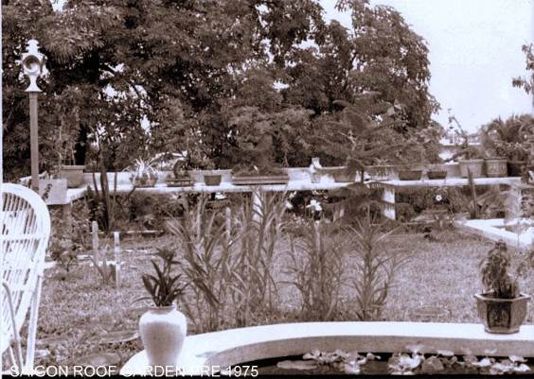

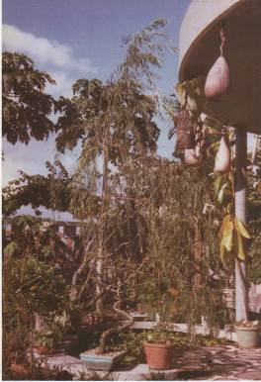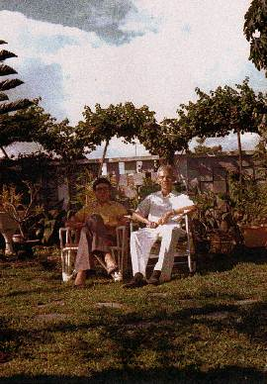
Roof garden
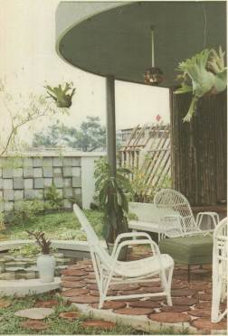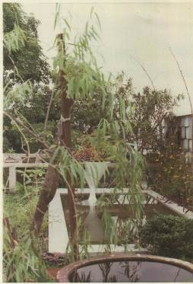
Saigon home roof garden

Now at the secret villa, we met our niece‘s family with the names listed on the priceless evacuation list. Either fate and destiny or God had added an asterisk with our names on that list. At that moment, I felt that life and death were delicately hung on a fragile spider web. A few hours later a van transported us to Tan Son Nhut airport. It was a scary moment when security agents checked all the passengers of the van. If they recognized any high officials, they would retain them for further interrogation. I was wearing a pair of heavy dark sun glasses and praying to God for a safe exit. Finally we were kept in the American bowling hall with several hundreds of other evacuees. About 24 hours later, we boarded a military transport C-141 Starlifter plane. The communist rockets kept hitting the airport and the plane’s engines never stopped running ready for take-off any time.
Evacuees sat on the floor of the plane like sardines. Finally the loud roaring of the engines signaled the beginning of a new life in the unknown.

The plane was heading for Manila but for some unknown reason, continued to Guam. We learned later that Marine Camp Pendleton was not ready to take the refugees. We stayed one week in Guam in military Quonset huts then finally continued to our new home in California.

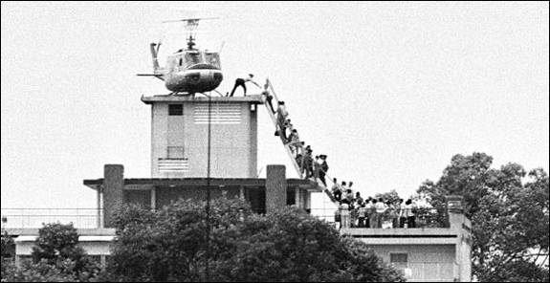
Before the collapse of Saigon, Marine helicopters kept loading evacuees on the roof of the US embassy

C-141 Starlifter
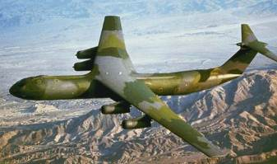

End of April 1975
Under communist rocket attack, a Marine C-141 Starlifter transported evacuees from Saigon Tan Son Nhut airport to Marine Airfield El Toro, near Camp Pendleton, California
We refugees’ safe arrival at Marine Camp Pendleton meant the beginning of a new life in the unknown for many of us. But thank God, we knew that it was a rebirth in the Land of the Free.

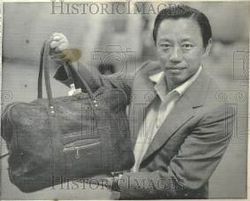
“ALL THAT’S LEFT” MAY 1975

CHAPTER 16

Refugees in Marine Camp Pendleton, Ca

==================
Về tác giả Khương Hữu Điểu
Than goi anh Hội trưởng Huỳnh Hường,
Toi Khuong Huu Dieu, 83 tuoi, la hoc sinh Le Myre de Vilers, Mytho nam 1944-48 va co tro ve Mytho day mot nam 1951-52 truoc khi duoc hoc bong sang My 1952. Toi co goi vai bai cho Đặc San hoi nha theo địa chỉ cũ.
Xin goi lai theo dia chi moi va nho anh cho biet y kien xem hội co y ddinh ddang hay khong?
Cam on anh,
Khuong Huu Dieu
(Phần sau cùng nầy là ghi chú của Hội Ái Hữu Cựu Học Sinh Giáo Sư và nhân viên Trung Học Nguyễn Đình Chiểu, Trung Học Lê Ngọc Hân và Đồng Hương Mỹ Tho )
(27-Jan-2013)

